**Assignment 3.6**

set hive.support.concurrency = true;

set hive.enforce.bucketing = true;

set hive.exec.dynamic.partition.mode = nonstrict;

set hive.txn.manager = org.apache.hadoop.hive.ql.lockmgr.DbTxnManager;

set hive.compactor.initiator.on = true;

set hive.compactor.worker.threads = a positive number on at least one instance of the Thrift metastore service;

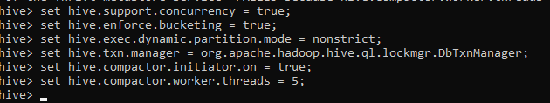

CREATE TABLE cmdb(id int, servername String, datacenter string) clustered by (datacenter) into 5 buckets stored as orc TBLPROPERTIES('transactional'='true');



INSERT INTO table cmdb values(1,'srv1','ASIA'),(2,'srv2','AMER'),(3,'srv3','ASIA'),(4,'srv4','AFRI'),(5,'srv5','EURO'),(6,'srv6','EURO'),(7,'srv7','AMER') ,(8,'srv8','AFRI') ,(9,'srv9','ASIA');



SELECT * FROM cmdb;

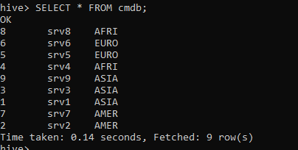

UPDATE cmdb set datacentre = 'USA' where datacentre = 'AMER';



UPDATE cmdb set servername = 'Cloud5' where servername = 'srv5';

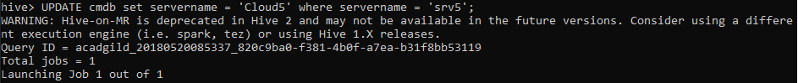

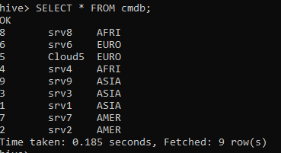

DELETE FROM cmdb where id = 7;



